Introduction
Natural selection occurs when organisms that have certain traits survive to reproduce more than organisms that lack those traits do. A population evolves when individuals with different genotypes survive or reproduce at different rates.
In this lab, you will model the selection of favorable traits in a new generation by using a paper model of a bird—the fictitious Egyptian origami bird (Avis papyrus), which lives in dry regions of North Africa. Assume that only birds that can successfully fly the long distance between water sources will live long enough to breed successfully.

Objectives
- We will model the process of selection.
- We will relate favorable mutations to selection and evolution.

Materials
- Scissors
- Construction paper
- Clear tape
- Soda straws
- Felt-tip marker
- Meter stick or tape measure
- Penny or other coin
- Six-sided die

Procedures
PART A: Parent Generation
- Cut two strips of paper, 2 X 20 cm each. Make a loop with one strip of paper, letting the paper overlap by 1 cm, and tape the loop closed. Repeat for the other strip.
- Tape one loop 3 cm from each end of the straw. Mark the front end of the bird with a felt-tip marker. This bird represents the parental generation.
- See how far your bird can fly by releasing it with a gentle overhand pitch.
- “Fly” the bird twice. Record the bird’s average flight distance in your data table.

PART B: First (F₁) Generation
- Each origami bird lays a clutch of three eggs. Assume that one of the chicks is a clone of the parent. Use the parent to represent this chick in step 7.
- Make two more chicks. Assume that these chicks have mutations. Follow Steps A—C below for each chick to determine the effects of its mutation.

Step A: Flip a coin to determine which bird is affected by a mutation.
Heads= anterior (front)
Tails = posterior (back)
Step B: Throw a die to determine how the mutation affects the wing.
= Wing position moves 1 cm towards the end of the straw.

= Wing position moves 1 cm towards the middle of the straw
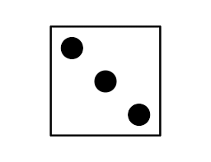= Wing circumference increases by 2 cm

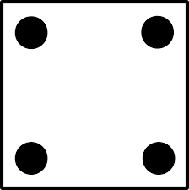 = Wing circumference decreases by 2 cm

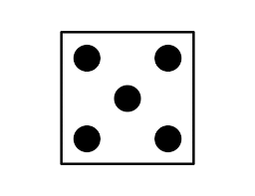= Wing width increases by 1 cm

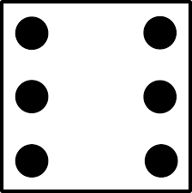 = Wing width decreases by 1 cm

Step C: A mutation is lethal if it causes a wing to fall off the straw or a wing with a circumference smaller than that of the straw. If you get a lethal mutation, disregard it and produce another chick.

- Record the mutations and the wing dimensions of each offspring.
- Test each bird twice by releasing it with a gentle overhand pitch. Release the birds as uniformly as possible. Record the distance each bird flies. The most successful bird is the one that flies the farthest.

PART C: Subsequent generations
- Assume that the most successful bird in the previous generation is the sole parent of the next generation. Repeat steps 5-7 using this bird.
- Continue to breed, test, and record data for eight more generations.
- After all testing is completed, dispose of all paper scraps in the proper receptacle. Clean your work area.

Data Table Anterior wing *(cm) Posterior wing (cm)
Bird | Coin Flip (H or T) | Die Throw (1-6) | Width (cm) | Circum. | Distance from front | Width | Circum. | Distance from back | Average distance flown
Parent | N/A | N/A | 2 | 19 | 3 | 2 | 19 | 3
Gen 1
Chick 1
Chick 2
Chick 3
Gen 2
Chick 1
Chick 2
Chick 3

Analysis and Conclusion
- Analyzing Results: Did the birds you made by modeling natural selection fly farther than the first bird you made?

- Inferring Conclusions: How might this lab help explain the variety of species of Galapagos finches?

